Test bank of questions that can be used for review and/or assessment. Some questions are a review from previous units, and some are specifically based on Unit 4 topics.

AP CSP Unit 4 Vocabulary
Iterative process | - Repeatedly taking small steps to build a whole solution  - Continuously adjusting the system to keep the error close to zero  - Automates control of a system by comparing the output state to input  - A marker placed on a line of code that causes the debugger to stop
List | - The number used to access an item in a list.  - An individual value in a list.  - An ordered collection of items.  - The number of items in a list.
Index | - The number used to access an item in a list.  - An individual value in a list.  - An ordered collection of items.  - The number of items in a list.
Element | - The number used to access an item in a list.  - An individual value in a list.  - An ordered collection of items.  - The number of items in a list.
Length | - The number used to access an item in a list.  - An individual value in a list.  - An ordered collection of items.  - The number of items in a list.
Global variable | - Specific numbers used in code that should be constants  - Variables defined inside a function  - Variables defined outside a function in the main program  - A list of variables declared in a function definition that receive values
Local variable | - Specific numbers used in code that should be constants  - Variables defined inside a function  - Variables defined outside a function in the main program  - A list of variables declared in a function definition that receive values

AP CSP Unit 4 Coding Questions
What does this code do?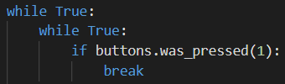 | - Waits for a button press to go again.  - Ends the code.  - Remote control for the ‘bot.  - Recalculates the distance.
How can you debounce the button? | - Hold the button for one second.  - Add a sleep() delay.  - Add another while loop to the code.  - Call buttons.was_pressed()
To make your code more readable, what section should go right after imports? | - Functions  - Constants  - Global variables  - The main program
What is the data type of this value:  5 | - Float  - Boolean  - Integer  - String  - List  - Tuple
What is the data type of this value:  (1, 0, 1, 0, 0) | - Float  - Boolean  - Integer  - String  - List  - Tuple
What is the data type of this value:  4.3 | - Float  - Boolean  - Integer  - String  - List  - Tuple
What is the data type of this value:  ‘Python’ | - Float  - Boolean  - Integer  - String  - List  - Tuple
What is the data type of this value:  False | - Float  - Boolean  - Integer  - String  - List  - Tuple
What is the data type of this value:  [400, 500, 600] | - Float  - Boolean  - Integer  - String  - List  - Tuple
What line of code initializes, or defines, a counter variable? | - count = 0  - count = count + 1  - if count == 1:  - def count = 0
What line of code increments a counter? | - count = 0  - count = count + 1  - if count == 1:  - def count = 0
What line of code compares a counter to 1? | - count = 0  - count = count + 1  - if count == 1:  - def count = 0
The following code is an example of:  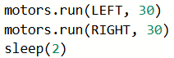 | - Iteration  - Selection  - Sequencing  - Randomization
The following code is an example of:  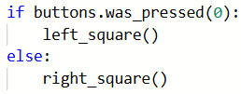 | - Iteration  - Selection  - Sequencing  - Randomization
The following code is an example of:  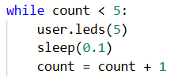 | - Iteration  - Selection  - Sequencing  - Randomization
What line of code defines an empty list? | - def new_list  - new_list = { }  - new_list = ( )  - new_list = [ ]
What code will add a new value to a list? | - my_list.append(new_value)  - my_list.add[new_value]  - append.new_list(new_value)  - add.new_list[new_value]
What is the value of freq after the code snippet is run?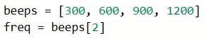 | - 2  - 600  - 900  - An error occurs
What is the final value of alist after this code segment is run?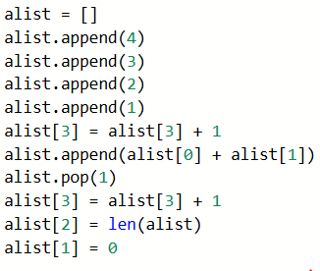 | - alist = [4, 0, 4, 8]  - alist = [4, 0, 2, 4, 8]  - alist = [0, 2, 5, 7]  - alist = [4, 0, 2, 5, 7]
What is the index of the first element in a list? | - 0  - 1  - A  - It depends on the elements in the list
What is the index of the last element in a list? | - len(the_list)  - len(the_list) - 1  - Z  - It depends on the elements in the list
This is an example of:  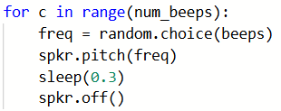 | - Accessing an element in a list  - Accessing a random element in a list  - Traversing a single list  - Traversing multiple lists
This is an example of:  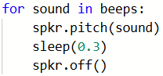 | - Accessing an element in a list  - Accessing a random element in a list  - Traversing a single list  - Traversing multiple lists
This is an example of:  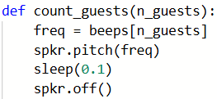 | - Accessing an element in a list  - Accessing a random element in a list  - Traversing a single list  - Traversing multiple lists
This is an example of:  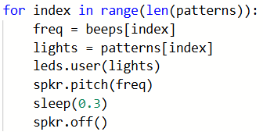 | - Accessing an element in a list  - Accessing a random element in a list  - Traversing a single list  - Traversing multiple lists
What is the correct function call for wait()?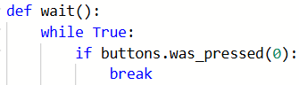 | - wait()  - wait(delay)  - def wait():  - done = wait()
What is the correct function call for my_function()?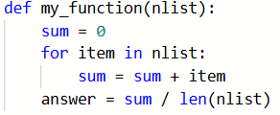 | - my_function()  - my_function(new_list)  - def my_function(nlist):  - answer = my_function(new_list)
In the function, what type of variable is nlist? | - Random  - Global  - Local  - Parameter
In the function, what type of variable is sum? | - Random  - Global  - Local  - Parameter
What does my_function() do? | - Calculates the sum of a list  - Finds the highest number in a list  - Calculates the average of a list  - An error occurs
What is the correct function call for does_something()?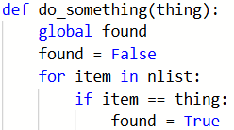 | - do_something()  - do_something(5)  - def do_something(thing):  - call do_something(thing)
In the function above, what type of variable is found? | - Random  - Global  - Local  - Parameter
In the function above, what type of variable is thing? | - Random  - Global  - Local  - Parameter
In the function above, what type of variable is item? | - Random  - Global  - Local  - Parameter
What does do_something() do? | - Searches a list for a specific item  - Calculates the total of a list  - Updates an element in a list  - An error occurs
What happens if you don’t use this code in your function?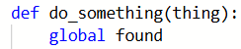 | - Your code will crash  - Nothing happens; the global line isn’t necessary  - It will make a local variable into a global  - It will make a global variable into a local

